Creating a System of Inequalities Activity

Step 1: Write a system of inequalities in the space below.
(Each partner will write one of the inequalities.)

Step 2: Use Desmos graphing calculator to graph your system of inequalities.
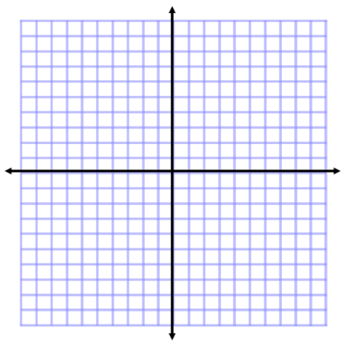
Show your results on this graph.

Step 3: Each partner is to change 1 thing about their partner’s inequality.
Show your changes below.
New System of Inequalities:

Step 4: Use Desmos graphing calculator to graph your new system of inequalities.
Show your results on this graph.
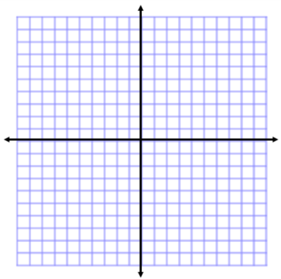

Step 5: Discuss with your partner how the changes affected the graph/solution.
Record your findings in the space below.

